Brain Tumor Detection from MRI Using Deep Learning


Student Name: Mohammad Dassan
ID: 20229502062
Course: Deep Learning
Department: Computer Engineering
University: German Jordanian University
Instructor: Dr. Nadia Alrousan

1. Project Idea & Problem Definition
Brain tumors are among the most critical neurological diseases, where early and accurate diagnosis plays a vital role in patient survival and treatment planning. Magnetic Resonance Imaging (MRI) is widely used for brain tumor detection due to its ability to capture detailed brain structures without ionizing radiation. However, manual interpretation of MRI scans is time-consuming and highly dependent on expert radiologists.

The goal of this project is to design and implement a deep learning-based system capable of automatically classifying brain MRI images into four categories:
- Glioma tumor
- Meningioma tumor
- Pituitary tumor
- No tumor

This project aims to demonstrate how Convolutional Neural Networks (CNNs) and transfer learning can be applied to medical image classification tasks, assisting healthcare professionals by providing fast, consistent, and reliable predictions.

2. Dataset Collection & Source Credibility

The dataset used in this project is “Brain Tumor Classification (MRI)”, obtained from Kaggle, a widely trusted platform for academic and research datasets.

Dataset link:
https://www.kaggle.com/datasets/sartajbhuvaji/brain-tumor-classification-mri

The dataset consists of labeled brain MRI images divided into:
- Training set
- Testing set

Each set contains four folders corresponding to the four classes. The images are grayscale MRI slices with consistent formatting, making the dataset suitable for supervised deep learning tasks. Kaggle datasets are commonly used in academic projects, ensuring credibility and reproducibility.

3. Exploratory Data Analysis (EDA)

Exploratory Data Analysis was performed to understand the dataset structure and challenges before model training.

Key observations:
- The dataset shows class imbalance, where some tumor types appear more frequently than others.
- Visual inspection revealed that glioma tumors exhibit high variability in shape, size, and texture.
- Pituitary and meningioma tumors are visually more consistent and easier to distinguish.

This analysis highlighted the need for:
- Data augmentation
- Class weighting
- A strong feature extractor

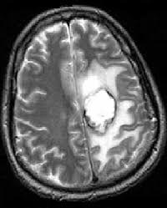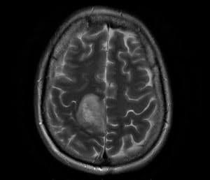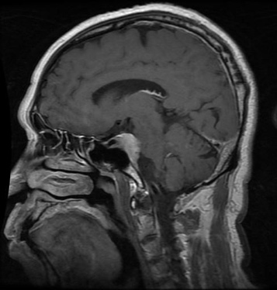

4. Data Preprocessing

Several preprocessing steps were applied to prepare the MRI images for deep learning:
- Image resizing
All images were resized to a fixed resolution of 256×256 pixels to ensure uniform input dimensions.
- Normalization
Images were normalized using EfficientNet preprocessing, which scales pixel values to match the distribution expected by the pre-trained network.
- Data augmentation
To reduce overfitting and improve generalization, the following augmentations were applied during training:
  - Random horizontal flipping
  - Random rotation
  - Random zoom
  - Random contrast adjustment
- Label encoding
Class labels were encoded using categorical (one-hot) representation.
- Class imbalance handling
Class weights were computed and applied during training to penalize misclassification of minority classes, especially glioma tumors.

5. Model Implementation

5.1 Architecture Choice

A Convolutional Neural Network (CNN) based on EfficientNetB0 was used with transfer learning.

EfficientNetB0 was selected because:
- It provides high accuracy with fewer parameters.
- It captures fine-grained spatial features, which are crucial for medical images.
- It performs better than lightweight models on complex visual patterns.

5.2 Model Structure
- Pre-trained EfficientNetB0 backbone (ImageNet weights)
- Global Average Pooling layer
- Dropout layer for regularization
- Fully connected softmax layer for 4-class classification

5.3 Training Strategy

Training was performed in two phases:
- Feature extraction: backbone frozen, training only the classifier head.
- Fine-tuning: deeper layers unfrozen with a smaller learning rate.

6. Training Process

The model was trained using:
- Optimizer: Adam
- Loss function: Categorical Cross-Entropy
- Batch size: 16
- Early stopping to prevent overfitting
- Learning rate reduction when validation loss plateaued

Training Curves

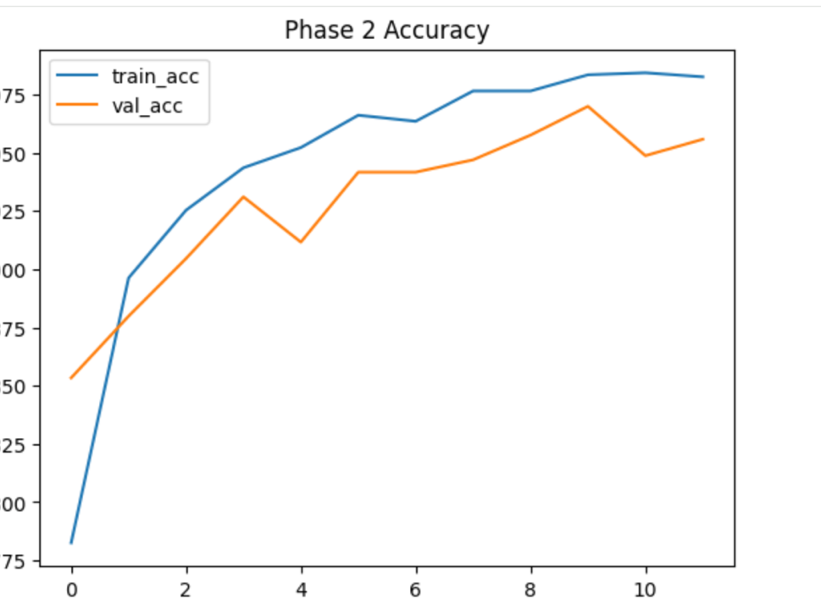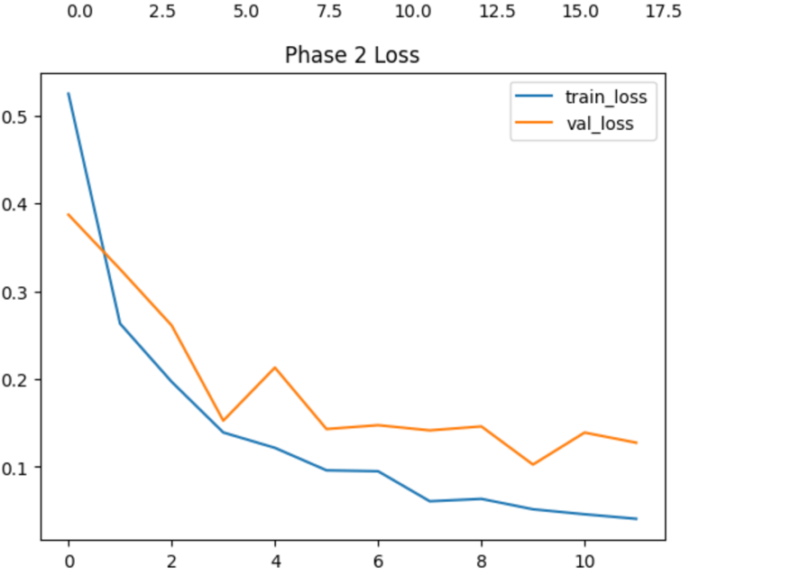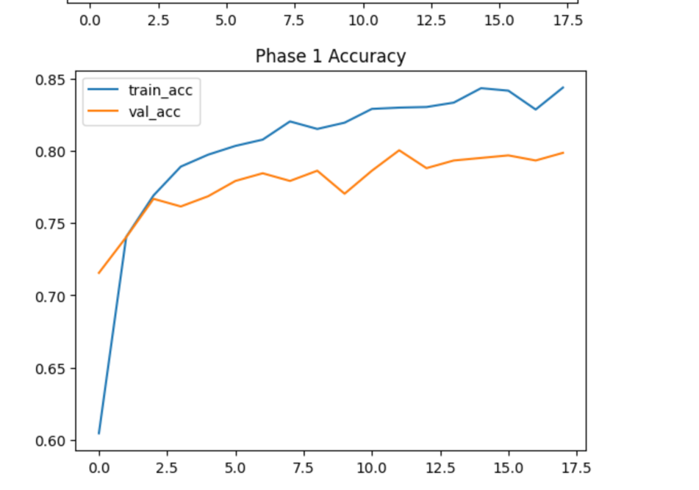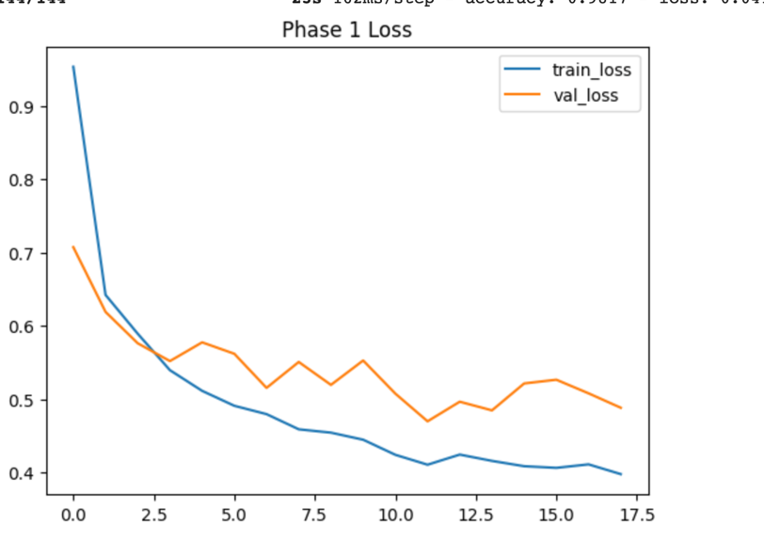
These curves show stable convergence and reduced overfitting after fine-tuning.

7. Model Comparison

Two main architectures were evaluated:

7.1 MobileNetV2
- Lightweight and fast
- Achieved ~75% accuracy
- Struggled with glioma detection
- Lower macro-average metrics

7.2 EfficientNetB0
- Higher representational power
- Achieved ~84% accuracy
- Better macro recall and F1-score
- Significant improvement in glioma recall
- More stable training behavior

Why EfficientNetB0 Was Chosen
- Better balanced performance across all classes
- Improved detection of difficult tumor types
- Acceptable trade-off between accuracy and training time

8. Performance Evaluation

The final model was evaluated on the test dataset using:
- Accuracy
- Precision
- Recall
- F1-score
- Confusion Matrix

Final Test Accuracy: 84%

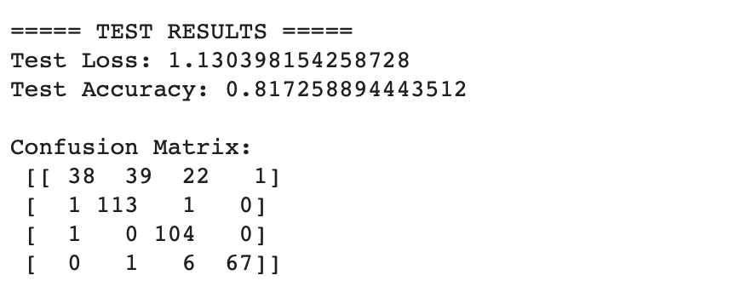

Class-wise Performance Summary
- Pituitary tumor: very high precision and recall
- Meningioma tumor: strong and consistent performance
- No tumor: almost perfect recall
- Glioma tumor: most challenging class, but recall improved significantly compared to earlier models

9. Example Prediction

The trained model was tested on unseen MRI images.

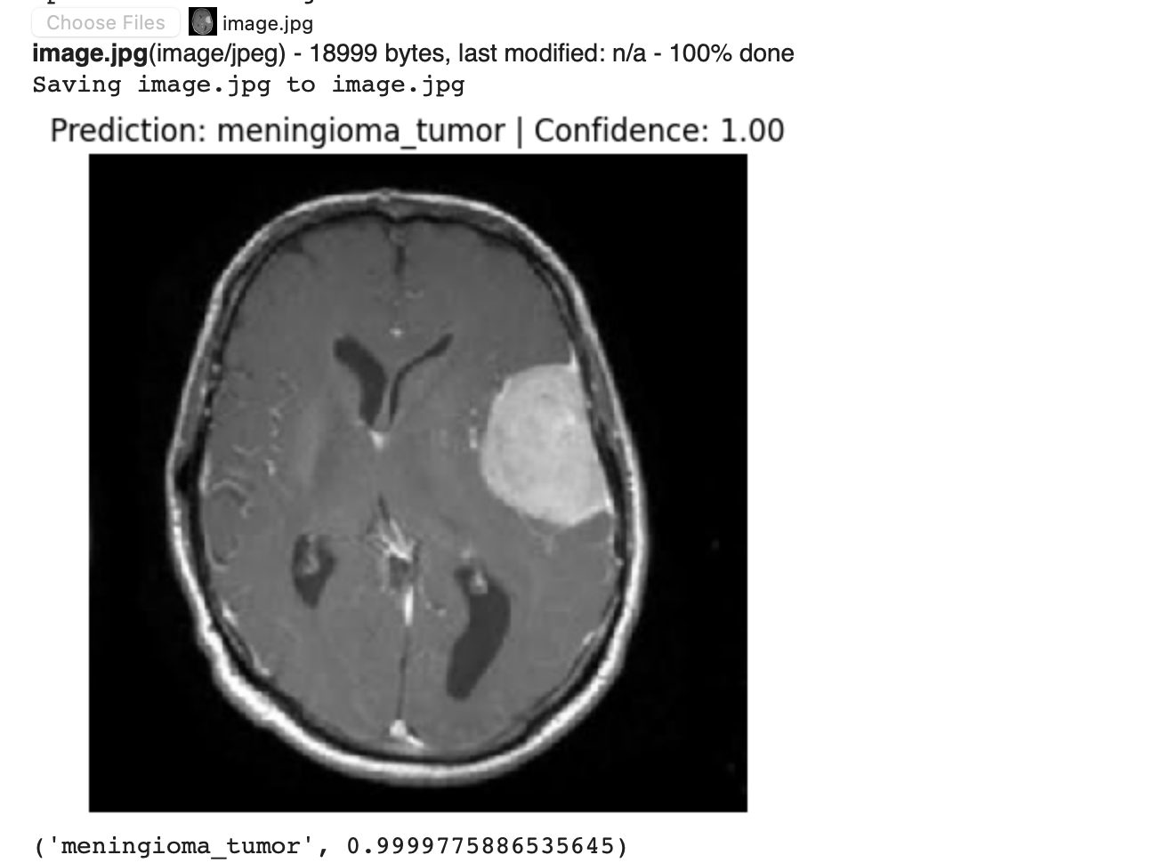
The model outputs:
- Predicted class
- Confidence score
- Probability distribution over all classes

This demonstrates the model’s ability to generalize to new inputs similar to the training distribution.

10. Discussion & Limitations

Despite strong overall performance, some limitations remain:
- Glioma tumors remain difficult due to high intra-class variability.
- Performance may degrade on external images with annotations or different acquisition settings (domain shift).
- The model is intended for educational and research purposes, not clinical diagnosis.

11. Conclusion

- This project demonstrates the effectiveness of deep learning and transfer learning in medical image classification. By leveraging EfficientNetB0, data augmentation, and class weighting, a robust multi-class brain tumor classifier was developed.

- The final model achieved 84% accuracy with strong balanced performance across tumor types. The project highlights both the potential and challenges of applying deep learning to real-world medical imaging tasks.

12. References
- Kaggle Dataset: Brain Tumor Classification (MRI)
- TensorFlow Documentation
- EfficientNet: Rethinking Model Scaling for CNNs

Future improvements could include:
- Using deep learning models such as LSTM or transformers
- Extending support to other languages and emojis
- Performing aspect-based sentiment analysis

